**D3 Times**

The D3 times analysis shows correlation between Poverty and Healthcare data. The data are available in a CSV file. Texas is among the high poverty states and highest among people who lack healthcare at 24.9 percent. 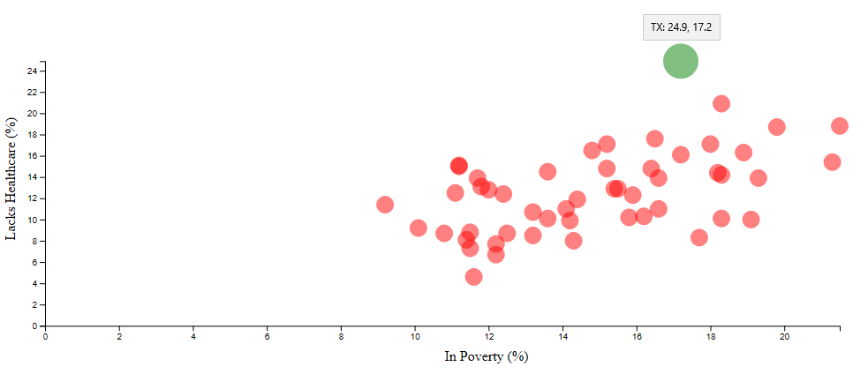

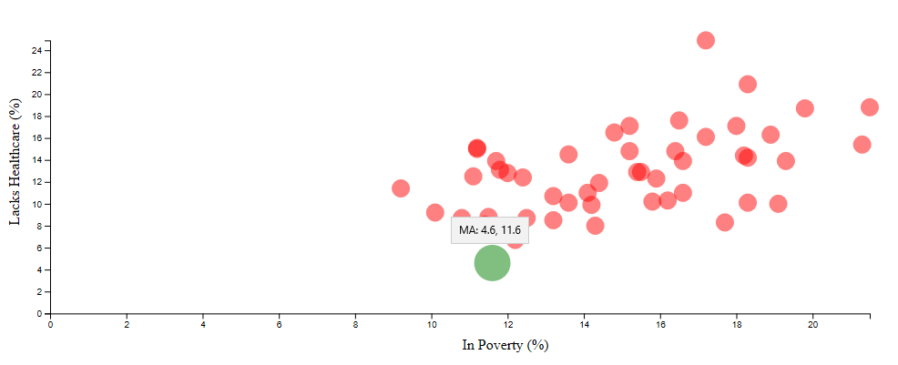

Massachusetts has the lowest poverty rate of 4.6 and the state is among the high healthcare states.

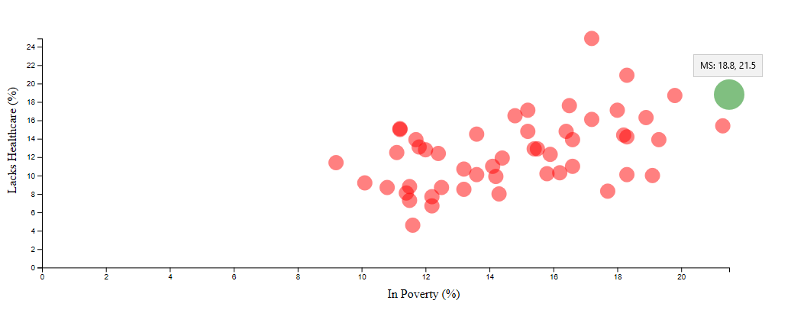

New Hampshire has the lowest poverty rate and Mississippi has the highest poverty rate among all states.

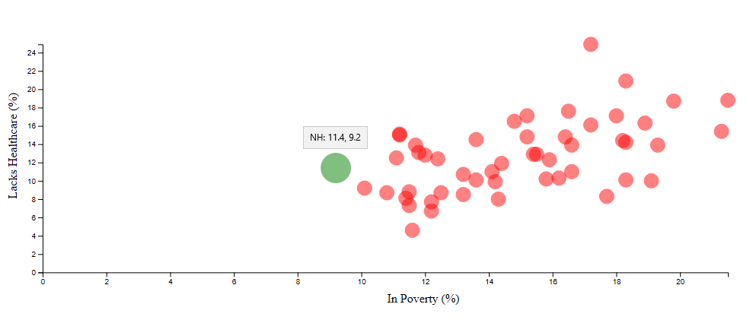

**Conclusion**

Health risks are higher in Texas due to lack of healthcare and lower in Massachusetts due to higher access to healthcare. Lower poverty states have better access to healthcare and higher poverty states lack or have lower access to healthcare.